**CRF 113868: Module of system automation for Share the RL Numbers to a vendor on daily basis.**

Query

select t.pledge_number, t.rl_no

from mana0809.tbl_auction_letter_his t

where tradate = trunc(sysdate - 60)

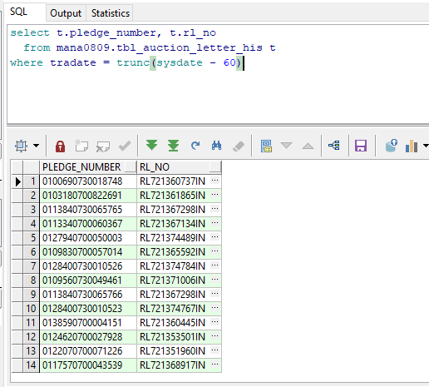

Mail Automation

